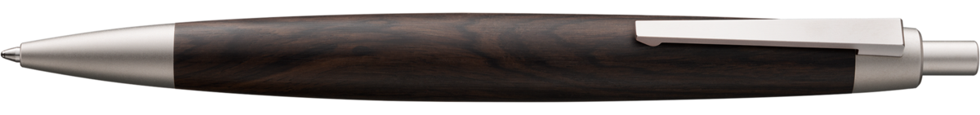

## The LAMY 2000 has been writing design history since 1966.

The LAMY 2000 brown is a limited edition fountain pen that celebrates the 55th anniversary of LAMY’s iconic design. Made from dark brown polycarbonate with a PVD-coated stainless steel clip, this pen is a collector’s item limited to 3,300 pieces. It features a platinum-refined 14-carat gold nib and comes in a sophisticated gift box with a leather-bound notebook and a biography of designer Gerd A. Müller1.